**‘Create New Breed’ Page** – This page is where you enter details of your new breed, such as its name, ideal weight, and its type of pet.

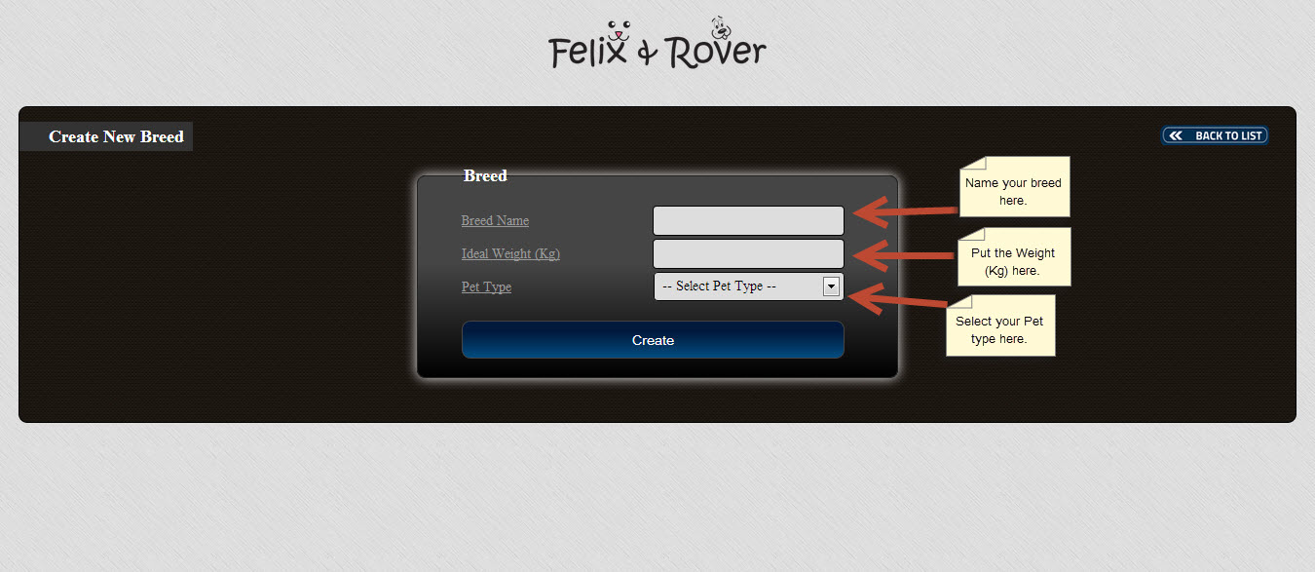

**‘List of Breeds’ Page** – This page shows you a detailed list of registered Breeds. Here, you will see the breed name, ideal weight, and the type of pet. You also have the option to edit or delete pet information, see pet details and enter new pet information.

